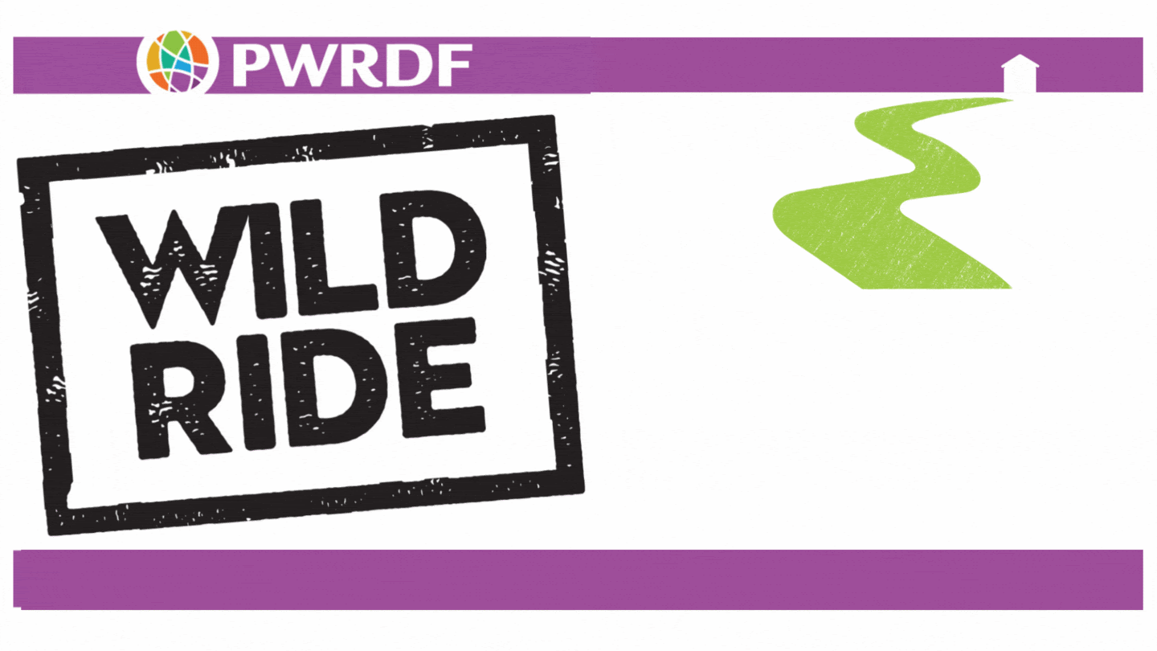

  June 20, 10 a.m. PT
  Wild Ride Launch Webinar
  The PWRDF Wild Ride returns from World Refugee Day, June 20, to Thanksgiving Day, October 14! PWRDF is marking 65 years of supporting refugees and internally displaced people. The Wild Ride is PWRDF’s peer-to-peer fundraising campaign that encourages people to bake, craft, run, walk, or read. You are invited to put your stamp on it by sharing your passion for a good cause. You can do an activity event or a challenge in a group or on your own to raise funds for PWRDF’s partners’ work with refugees and internally displaced people.
  Join us for the launch event on June 20 from 10 to 11:30 p.m. PT to learn what is in store for 2024.
  Register for the webinar!

